**Team Project:**

**Deliverable 4 – Project Phase 2**

**CSCE 5430 (Spring 2023)**

**Project Title:**

**Online Library Management System**

**Group Name:**

**Penguins**

**Group Members:**

| **No.** | **Name** | **Student ID** | **Email** |
| --- | --- | --- | --- |
| 1 | Ashraf Syed | 11618668 | AshrafSyed@my.unt.edu |
| 2 | Padmini Kuchukulla | 11605145 | KuchukullaPadminiLNU@my.unt.edu |
| 3 | Abhijith Reddy Mandagiri | 11603247 | AbhijithReddyMandagiri@my.unt.edu |
| 4 | Deepna Thalanki | 11644830 | deepnathalanki@my.unt.edu |
| 5 | Raghu Vamsi Kondapalli | 11663360 | raghuvamsikondapalli@my.unt.edu |
| 6 | Vamsi Venkat Manepalli | 11656561 | Vamsivenkatmanepalli@my.unt.edu |
| 7 | Sai Vishwak Jadala | 11673439 | saivishwakjadala@my.unt.edu |

**2.Report**

**a.Requirements**

The phase 2 of the project development plans have changed from our initial plan. We have changed the plan from developing only Admin features for phase 2 to including both major features of student and admin to phase 2. But not all features are added, only the common pages with similar page structure for both admin and student are included in this phase. The reason for changing the initial plan is that, after the previous code inspection session with the Team Achievers, based on the suggestions they have given to our previous phase, we believe keeping a buffer scope in our final phase will give us a good opportunity to incorporate all the suggestions and make the project to the best of our abilities. The updated phase 3 will be the addition of features like voice-based search, Automatic categorization, payment gateway and implementing any recommended changes or updates given during the peer evaluation.

**FUNCTIONAL REQUIREMENTS:**

**New User Registration:**

**Description of feature:**

All users i.e., students in this context have the option to use this feature to provide their contact information when creating accounts. This information includes name, email address, and contact number etc. as part of the registration process.

**Functional requirements:**

The system must be able to validate data and establish whether all the data was provided by the user, among other functional requirements. This would also provide the much-needed security and authenticity to the user login.

**User Login:**

**Description of feature:**

The user logs into the system using this function. Before logging on, they must input their user ID and password for authentication. The user cannot access the system if they are invalid. If a user forgets their password, the system should offer a mechanism to reset it. This is accomplished by sending a reset code to their registered cellphone number.

**Functional requirements:**

When a user registers, they supply a user id (like that of student id). To access the system, the user must identify themselves with a valid user id and password. The system then executes an authorization procedure to determine what user level has access.

**Functional requirements:**

The user must have the capacity to log out after they are done using the system. The system should restrict access to specific features or data based on the user's role in the library system, such as a librarian or a user.

**Admin User:**

**Register New Book:**

**Description of feature:**

With this feature, the administrator alone can have the access to include new books in the library. Based on necessities of the students, the admin has this feature to add new books to the system for expanding the horizon of the options for the students

**Functional requirements:**

Information verification capabilities for systems are required. Only authenticated users are allowed to access this page and use the feature for the required purposes.

**Functional requirements:**

The database table must be able to accept entries from the system for book information and copy count. The entry of the new book must follow all the proper schema set by the database for proper inclusion.

**Functional requirements:**

The system needs to be able to prevent two books from sharing the same book id. The primary key of the database does not allow for duplication.

**Issue and Returned Books:**

**Description of feature:**

This function enables the administrator to issue and receive books as well as see reports on books issued. It’s an exclusive feature for the admin, which allows them to manage the inventory of the library by keeping track of the books being checked out and checked in.

**Functional requirements:**

The number of books must be updated by the system, each time a book is checked out, it’s the admins job to assure that the database is updated for every transaction taking place. Just to make sure the database doesn’t fall into redundancy.

**Functional requirements:**

The system must be able to verify that the book is available before distributing it. Book would only be issued to a student, if there is a copy of the book available in the database that hasn’t already been issued.

**Functional requirements:**

Information about the issue and return dates, with the return date set to 15 days. The system should set a timer and update it daily to back track to the finish of 15 days limit.

**Functional requirements:**

The system should set due dates for loaned books and notify users through email or their mobile device when they are past due. The above requirement will help in assisting to this feature of notifying the student.

**Functional requirements:**

The system should keep track of returned books and make sure they are appropriately added back to the database count of the library system.

**View Registered Students:**

**Description of feature:**

The admin user has a page to view a report of the students who have registered with the system. This allows the admin to keep track of all the interactions a given student is having with the system and maintain stability of the library inventory.

**Functional requirements:**

The page will have a search feature that enables the admin to track a particular student using their name or student ID number. This allows the admin to check for deadlines and potential dues that the student owes to the library.

**Student User:**

**View Books Issued to the user:**

**Description of feature:**

The system should make it possible for the student to examine their personal data, including their name, student ID, contact details, and borrowing history. Students can view the books that have been issued to them using this page.

**Functional requirements:**

If the item is not overdue and has not been requested by another user, the system should enable the student to renew it. This would allow for the student to retain the book without causing any conflicts with other requests for that book.

**Performance Requirements**

**Response Time** - The system must react quickly and effectively as users look for books, borrow and return books, and manage their accounts. The communication between the front end and the backend must be precise and fast.

**Availability**- The system should be available 24/7 so that users can utilize it whenever they want. As little downtime as possible should be built into the system, and any upgrades or maintenance should be scheduled for off-peak hours.

**Scalability** - To handle an increase in users, transactions, and data without impacting its functionality, the system must be scalable. To support future development, hardware and software should be updated in accordance with the architecture of the system.

**Security** - To handle an increase in users, transactions, and data without impacting its functionality, the system must be scalable. To support future development, hardware and software should be updated in accordance with the architecture of the system.

**Usability** - The user interface must be straightforward, easy to use, and uncomplicated. These requirements must be taken into consideration while designing the system's user interface, which should also provide clear, comprehensive instructions for using it.

**Design Constraints**

**Web support:**

As the complete program will be placed onto the cloud, a crucial support that is required is the web. The project's functionality depends heavily on having access to the internet and maintaining the servers.

**Language support:**

English being the well-known famous language, the entire web-app is in English. Support for other languages might be difficult to achieve.

**Security:**

This being the major phase of the project development, the project has been developed with extreme security in mind and the best experience for the user in mind.

**Other Requirements:**

**Internal Interface Requirements:**

An internal interface for the online computerization of library activities is frequently made up of a collection of software packages or modules designed to manage various aspects of library operations. The following are some crucial components that could be present: Using the cataloging module, library employees can create, maintain, and update the catalog of books and other things. It frequently offers capabilities for filtering, sorting, and catalog searching. The circulation module allows for the lending and borrowing of library materials. It can be used by the staff to control fines and fees, maintain tabs on material issues and due dates, and check items in and out.

**Reports Module:**

Users have access to reports and information on library operations using this module. There may be statistics on catalog usage, circulation, and other important factors. Databases, books, and journals are just a few of the electronic resources the library manages with the help of this module. It might be able to measure usage, control access, authenticate users, and report on that usage.

**NON-FUNCTIONAL REQUIREMENTS:**

**Requirements Of Product:**

**Requirement Efficiency:**

Staff members of the Library and patrons will have quick access to books due to the computerization of library operations like issuing, tracking and fine calculation etc.

**Reliability Requirement:**

The system will accurately be able to handle member registration, member validation, book classification, transaction and search, and fine calculation, if necessary and any other tasks of the project. The project being sophisticated and reliable becomes our major priority.

**Performance:**

While managing large volumes of data and users via the system, there shouldn't be any latency or delay. Any transactions occurring in the system will have the same experience for every user making sure they have a good and positive experience.

**Demand for Usability:**

The web has been created in a way that is straightforward, sophisticated, and user-friendly. Any user, whether an administrator or a student, will find it incredibly simple and comfortable to browse about the website in order to finish any activities or occupations for which they are utilizing it.

**Scalability:**

The system will be designed keeping in mind future potential for growth and changes to the functionalities. The desire would be to keep it scalable to software growth and to the user’s threshold for the website.

**Organizational Requirements:**

**Implementation Requirements:**

The complete system is developed using Python Django as the back end and HTML as the front end. Database storage will be handled by PostgreSQL, while database connectivity will be handled by the Django framework along with the unit tests for the project.

**b.UML Design**

**UML**

**Class diagram -** It shows the static view of the system. Here we have multiple components like book, librarian, student, book item, account, book lending and fine. Each component has multiple entities associated with it.

|  |  |
| --- | --- |
|  |  |

**Sequence diagram -** It shows the time sequence associated with the object

interactions.Here we have multiple use cases like handling book details, search books and issue books. Below are the sequence diagrams.

**Handle Book Details**

|  |  |
| --- | --- |
|  |  |

**Search Books**

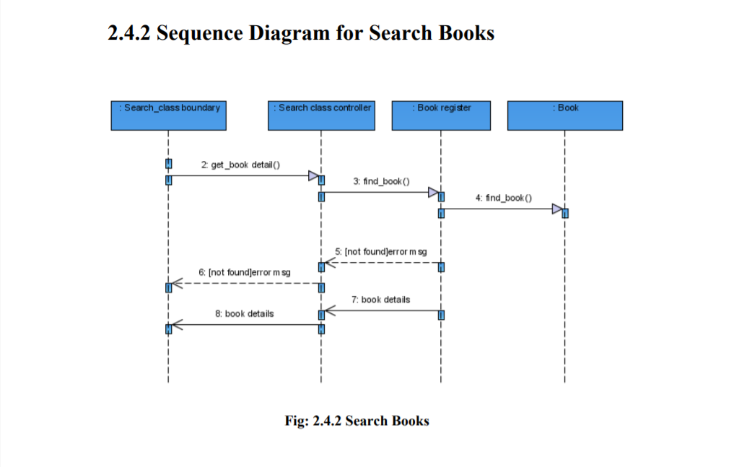

**Issue Book**

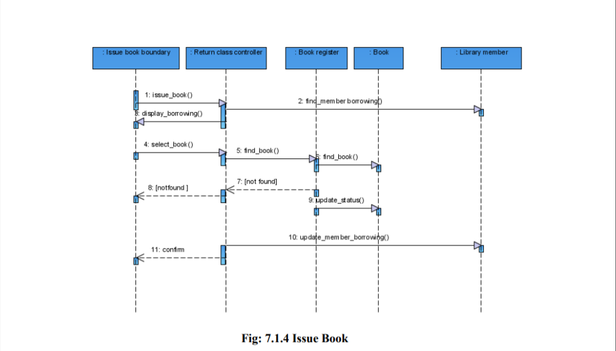

**Use case diagram -** This shows the relations between use cases and actors. Below is the diagram that depicts how a student can do multiple actions in the Online Library Management System

**Success Diagram**

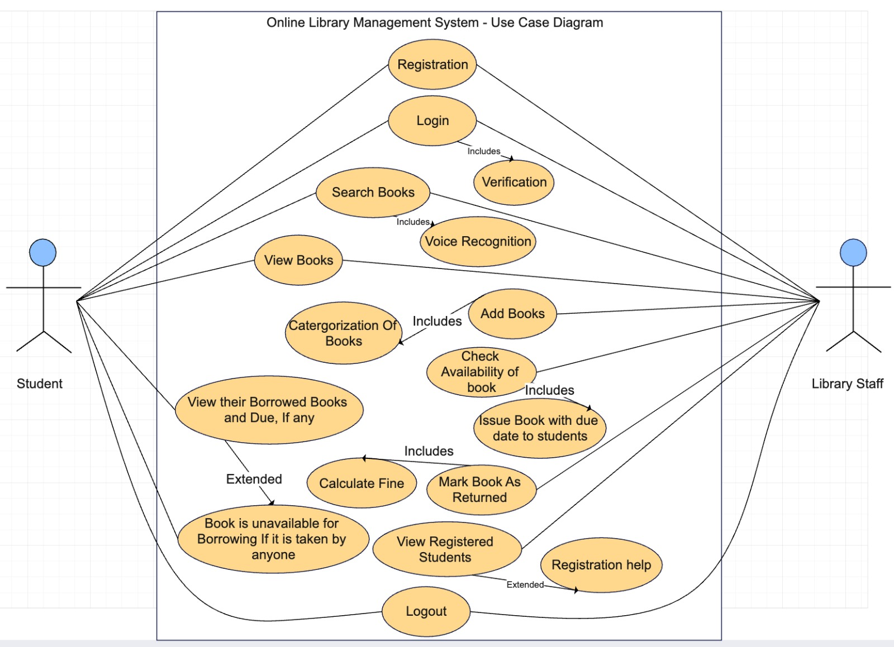

**Error Case Diagram**

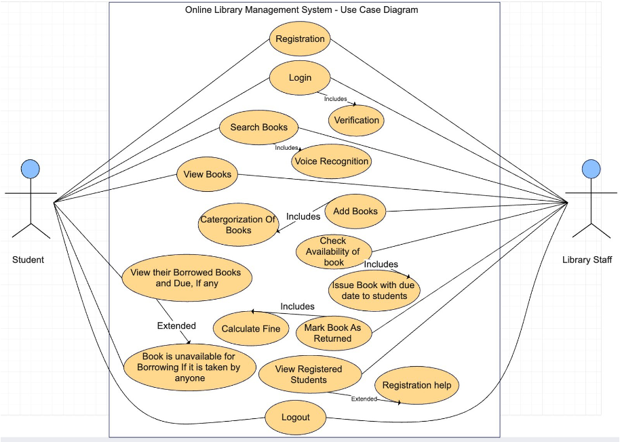

**c. Test Cases**

For our project we are using the Django Framework for the unit test cases. They are as follows:

**Student Signup**

1. We are using Django Framework
2. This is a unit test case for the student signup page where we have included characters like username, email, password, firstname, lastname, enrollment, branch.

response = self.client.post(self.url, data)

self.assertEqual(response.status_code, 302) # redirect to studentlogin

self.assertEqual(User.objects.count(), 1)

user = User.objects.first()

self.assertEqual(user.username, 'dg0107')

self.assertEqual(user.email, 'deepthipasamgnana@gmail.com')

self.assertTrue(user.check_password('Deepthi@0107'))

self.assertEqual(user.first_name, 'Deepthi')

self.assertEqual(user.last_name, 'Gnana')

self.assertEqual(user.enrollment, 'Masters')

self.assertEqual(user.branch, 'CS')

self.assertTrue(user.groups.filter(name='STUDENT').exists())

**Admin Signup**

1. We are using Django Framework
2. This is an unit test case for admins signup page where we have included characters like username, email, password, firstname, lastname, enrollment, branch.

response = self.client.post(self.url, data)

self.assertEqual(response.status_code, 302) # redirect to adminlogin

self.assertEqual(User.objects.count(), 1)

user = User.objects.first()

self.assertEqual(user.username, 'snr3110')

self.assertEqual(user.firstname, 'Sreeja')

self.assertEqual(user.lastname, 'Nanyala')

self.assertTrue(user.check_password('Sreeja@2001'))

self.assertTrue(user.groups.filter(name='ADMIN').exists())

**Admin Login**

1. We are using Django Framework
2. We are providing username and password, if they're true and then we hit the submit then the Admin gets logged in successful.
3. Input characters of username and password are sent to pushbutton(Login) which analyzes whether it is true or false and allows Admin to get logged in.

response = self.client.post(self.url, data)

self.assertEqual(response.status_code, 302) # redirect to admin home

self.assertEqual(User.objects.count(), 1)

user = User.objects.first()

self.assertEqual(user.username, 'snr3110')

self.assertTrue(user.check_password('Sreeja@2001'))

**Student Login**

1. We are using Django Framework
2. We are providing username and password, if they're true and then we hit the submit then the admin gets logged in successfully.
3. Input characters of username and password are sent to pushbutton(Login) which analyzes whether it is true or false and allows the admin to get logged in.

response = self.client.post(self.url, data)

self.assertEqual(response.status_code, 302) # redirect to student home

self.assertEqual(User.objects.count(), 1)

user = User.objects.first()

self.assertEqual(user.username, 'dg0107')

self.assertTrue(user.check_password('Deepthi@0107'))

**Error Test Cases.**

**Student signup**

1. We are using Django Framework
2. We are providing username and password, if the details entered by a student are incorrect/ False then this page doesn't allow the student to get signed in/ create an account.

response = self.client.post(self.url, data)

self.assertEqual(response.status_code, 302) # redirect to studentlogin

self.assertEqual(User.objects.count(), 1)

user = User.objects.first()

self.assertEqual(user.username, 'dg0107')

self.assertEqual(user.email, 'deepthipasamgnana@gmail.com')

self.assertFalse(user.check_password('Deepthi@0108'))

self.assertEqual(user.first_name, 'Deepthi')

self.assertEqual(user.last_name, 'Gnana')

self.assertEqual(user.enrollment, 'Masters')

self.assertEqual(user.branch, 'CS')

self.assertTrue(user.groups.filter(name='STUDENT').exists())

**Admin Signup**

1. We are using Django Framework
2. We are providing username and password, if the details entered by an Admin are incorrect/ False then this page doesn't allow the Admin to get signed in/ create an account.

response = self.client.post(self.url, data)

self.assertEqual(response.status_code, 302) # redirect to adminlogin

self.assertEqual(User.objects.count(), 1)

user = User.objects.first()

self.assertEqual(user.username, 'snr3110')

self.assertEqual(user.firstname, 'Sreeja')

self.assertEqual(user.lastname, 'Nandyala')

self.assertFalse(user.check_password('Sreeja@2002'))

self.assertTrue(user.groups.filter(name='ADMIN').exists())

**Admin Login**

1. We are using Django Framework
2. If the provided details of Admin(username and password) are incorrect i.e it does not match according to the Admin gets signed up then the Admin cannot get logged in.

response = self.client.post(self.url, data)

self.assertEqual(response.status_code, 302) # redirect to admin home

self.assertEqual(User.objects.count(), 1)

user = User.objects.first()

self.assertEqual(user.username, 'snr3110')

self.assertFalse(user.check_password('Sreeja@2002'))

**Student Login**

1. We are using Django Framework
2. If the provided details of Student (username and password) are incorrect i.e it does not match according to the student gets signed up then the Student cannot get logged in.

response = self.client.post(self.url, data)

self.assertEqual(response.status_code, 302) # redirect to student home

self.assertEqual(User.objects.count(), 1)

user = User.objects.first()

self.assertEqual(user.username, 'dg0107')

self.assertFalse(user.check_password('Deepthi@0108'))

**assertEqual(user.branch, 'CS')**

**d. User Manual**

Since our project is designing a web page for Online Library Management System, the end user is provided with the following link

<http://127.0.0.1:8000/>, which navigates to our web page.

The home page of our website for the end user looks like

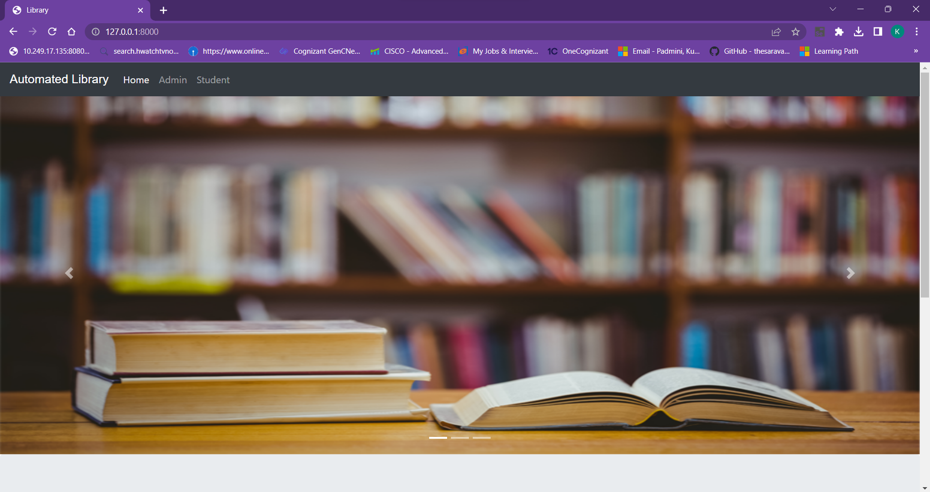

As he/she scrolls down, will be able to see the following, where there are two different portals i.e, Admin and Student.

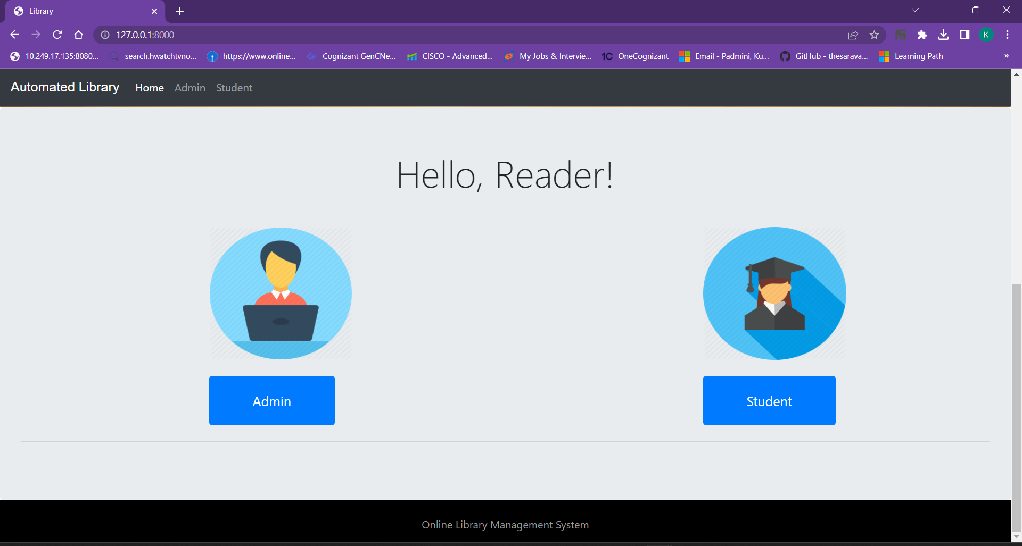

Now, if he/she wants to enter into the Admin portal, then he/she can either click the Admin button which is in blue color or directly the Admin button which is on the top left corner of the screen.Then, he/she can view the following

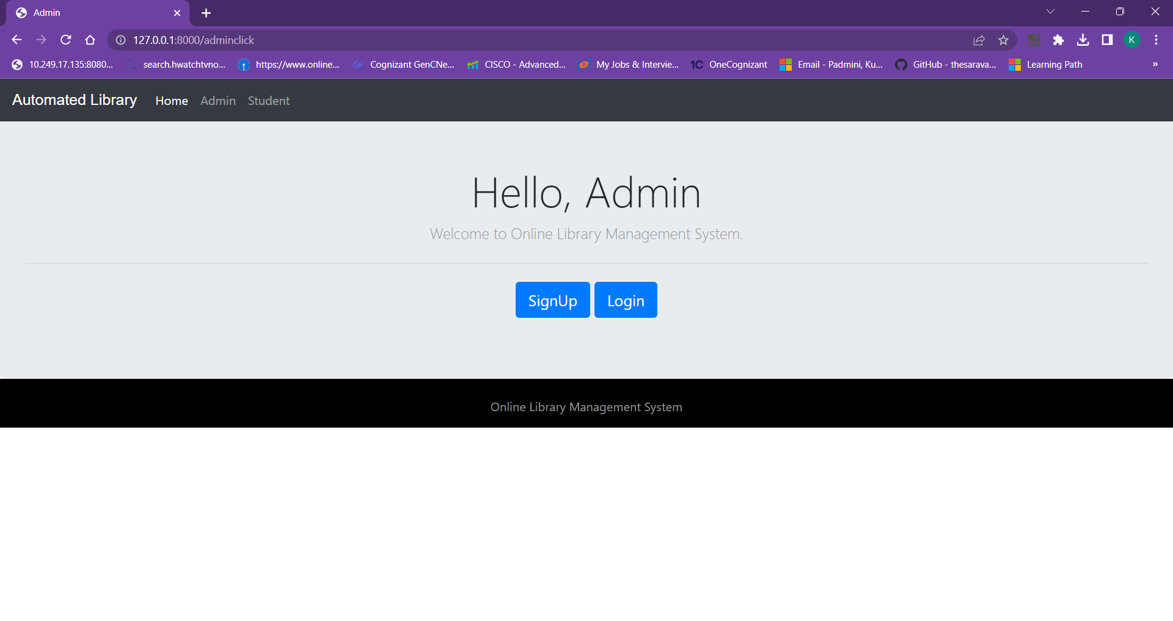

If the user is using our website for the first time, he/she can click on the signup. This redirects the user to the admin signup page, which looks like the following

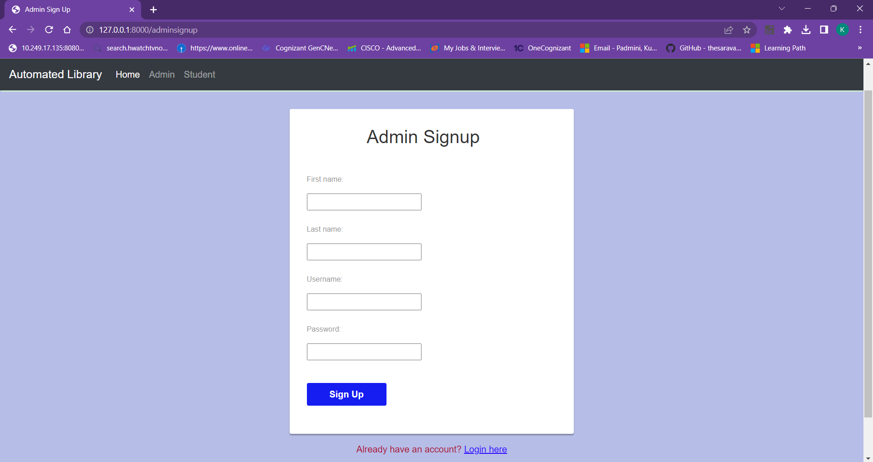

Provide the required details for signing up as shown below.

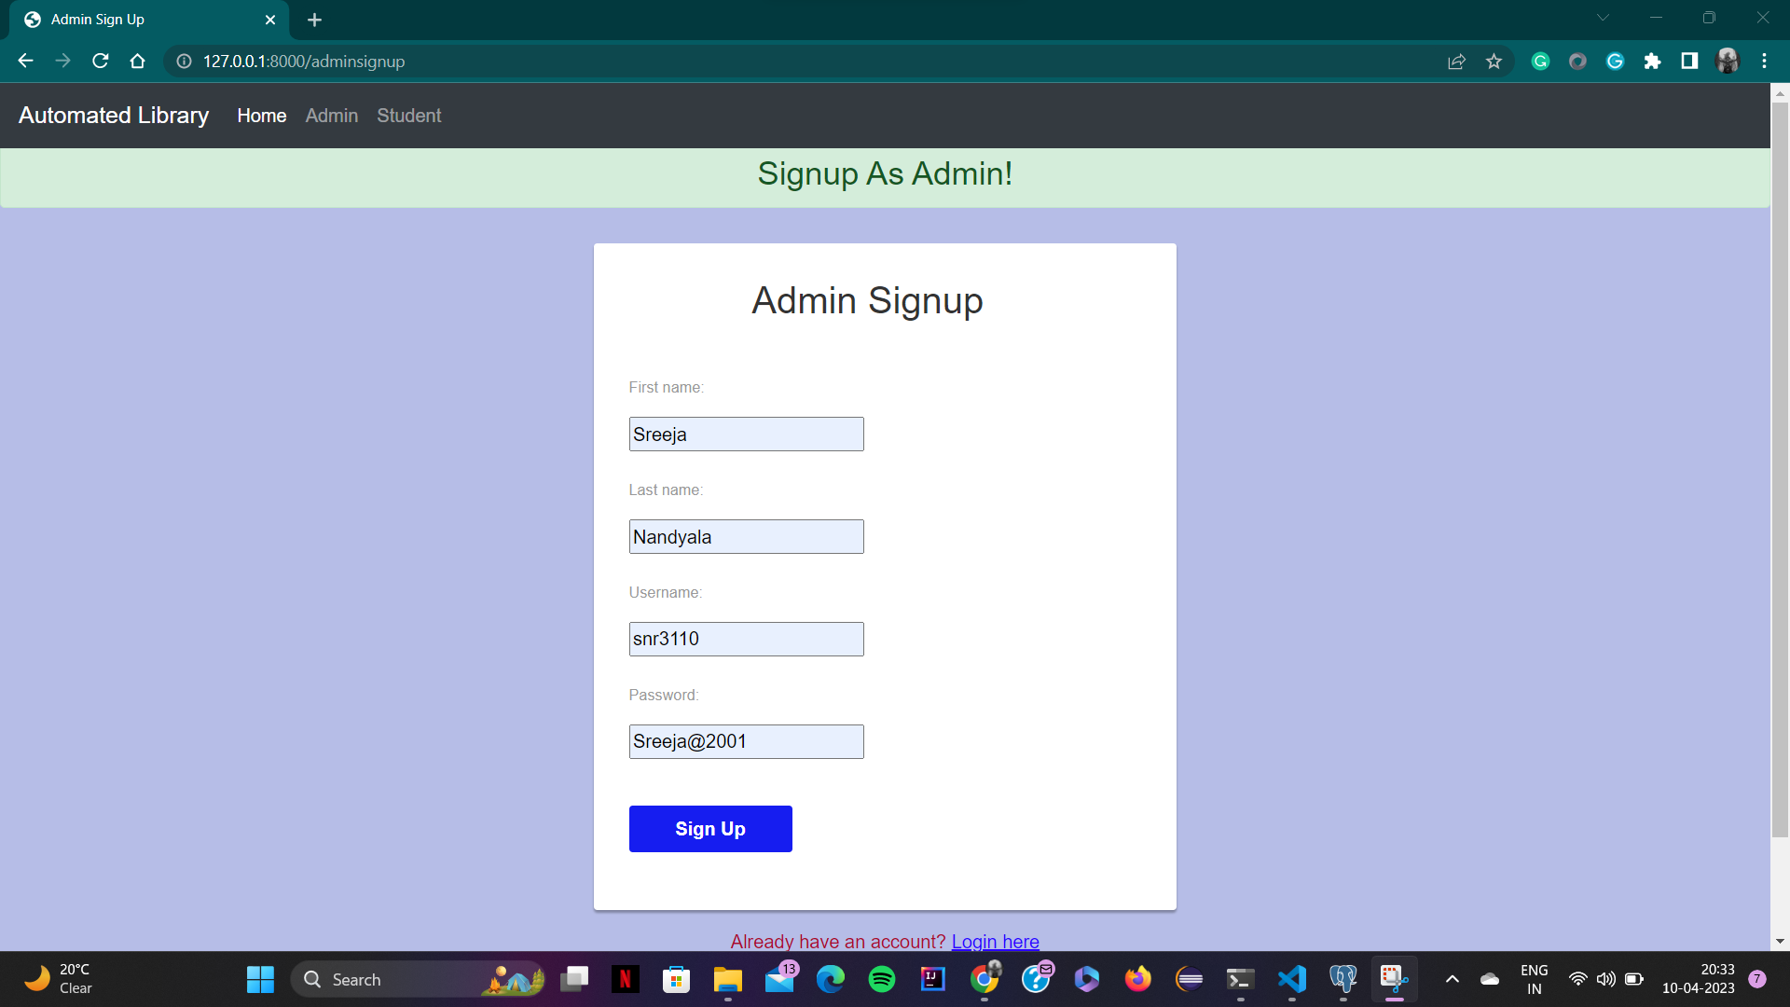

After giving details, one can click on the Sign Up button. Then, it redirects to the login page as below.

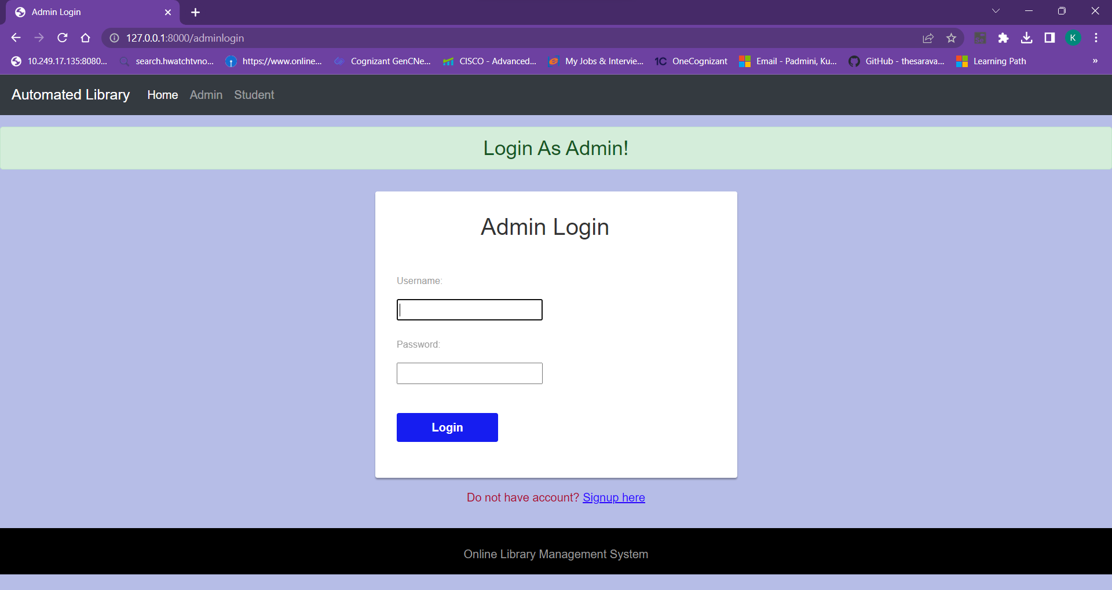

Give the details as given in the previous page to login as admin.

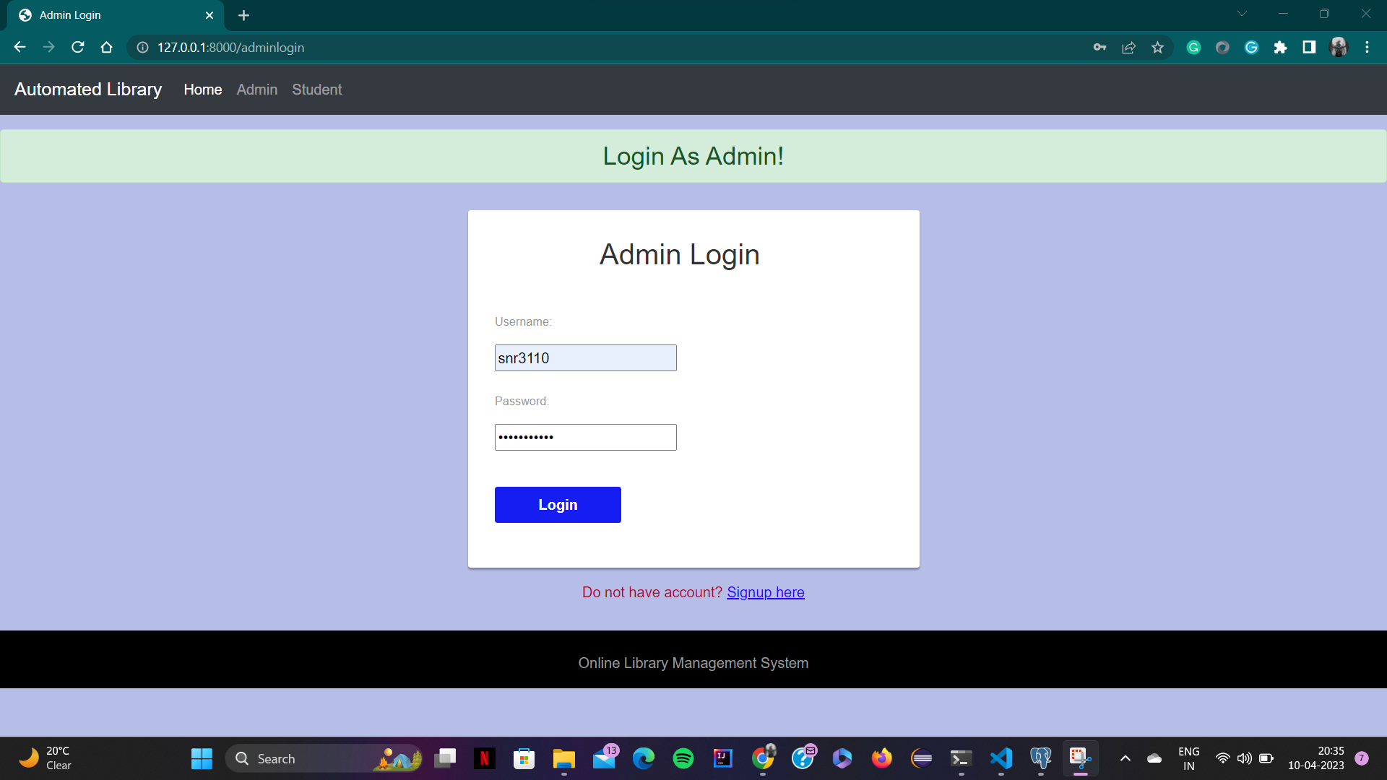

After successful login, one can view what all the functionalities can be performed by admin as below.

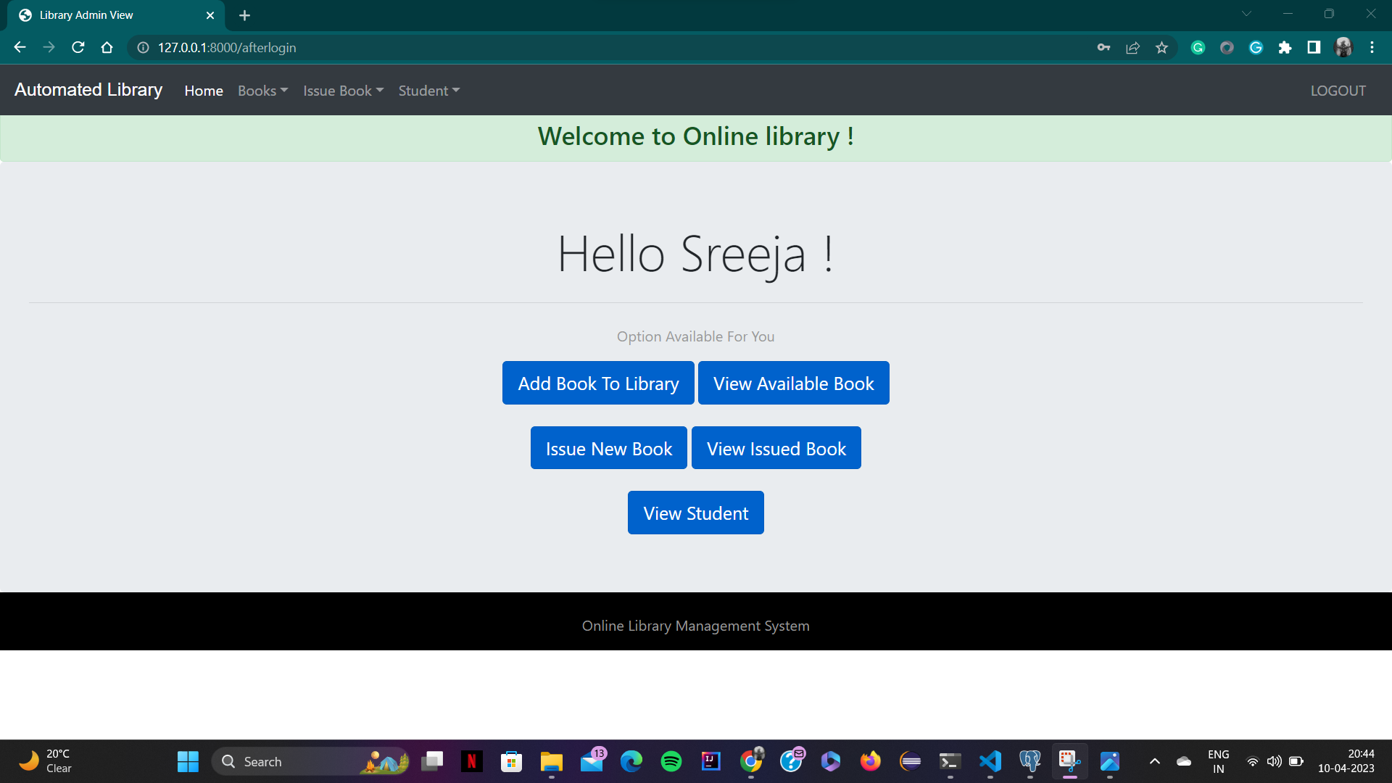

Now, the admin can add books to the library by clicking on the add book to library button as shown below.

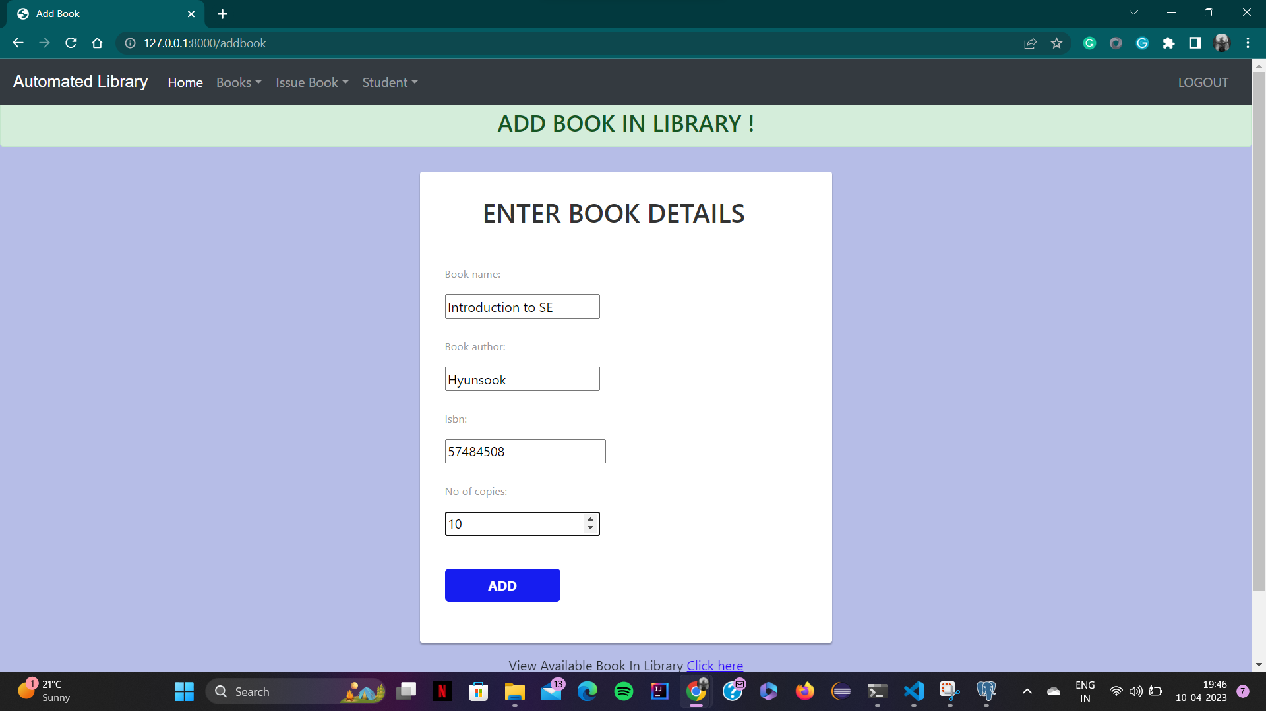

Now after giving the details of book, click on add button then one can view the resulting page as below.

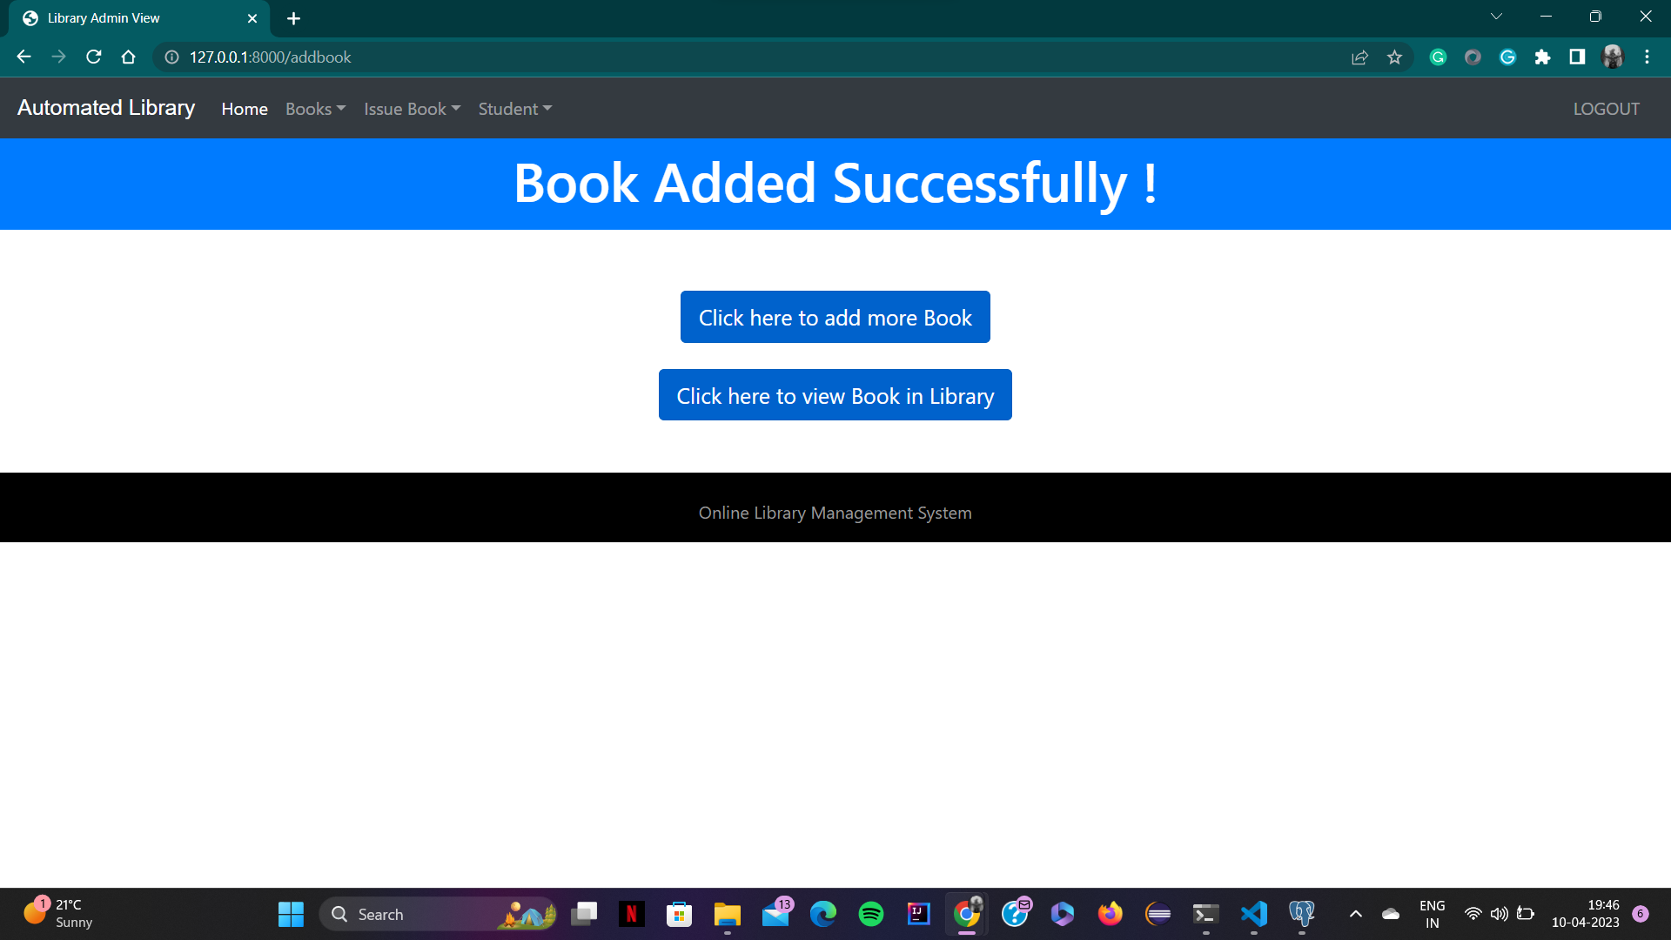

Now, to view all the books in the library click on “click here to view book in library” button. After clicking the button one will be redirected to the following page

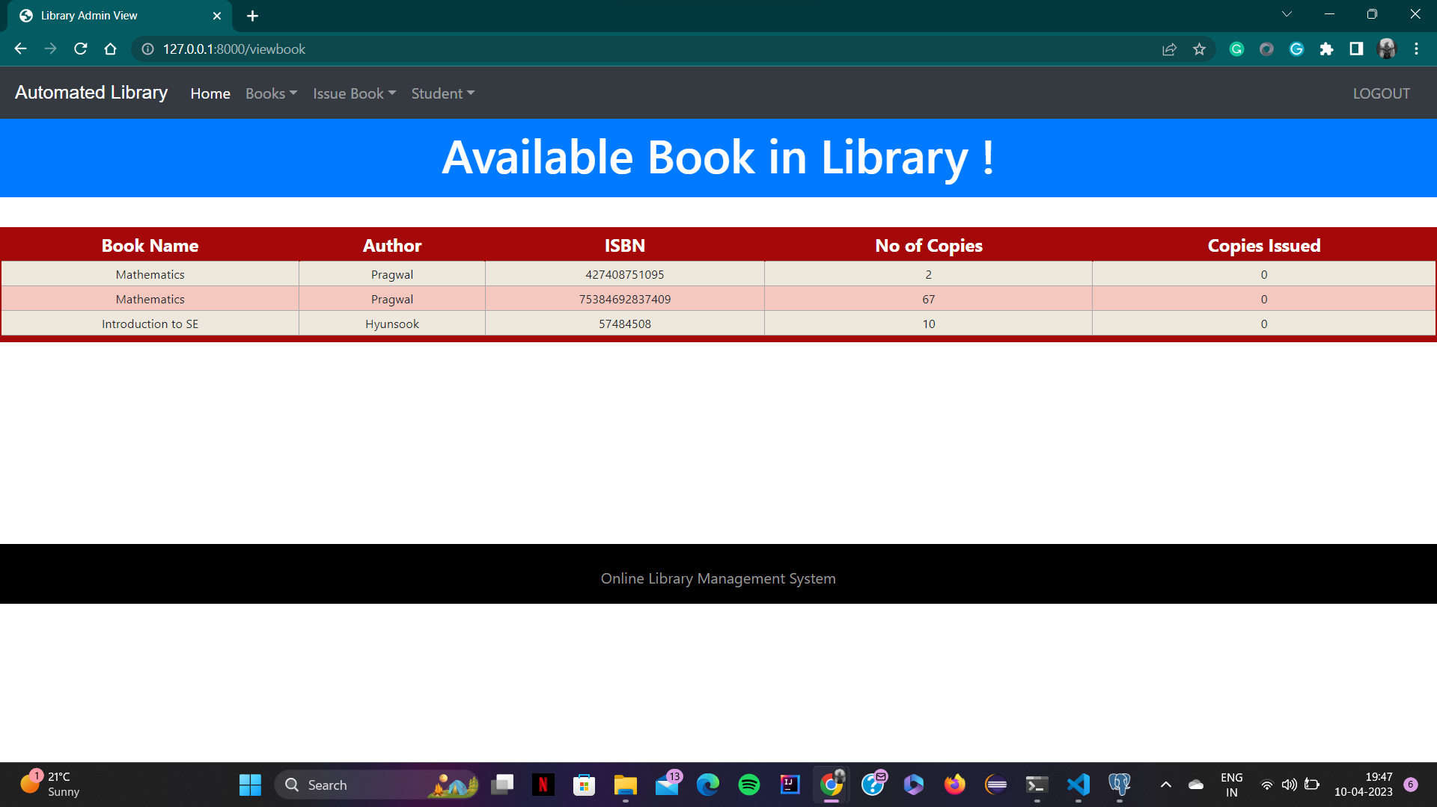

The other functionality of admin is to issue books available to students, which can be done by clicking the “Issue new book” button, which appears on the admin after login page. By clicking this button one can see as the following

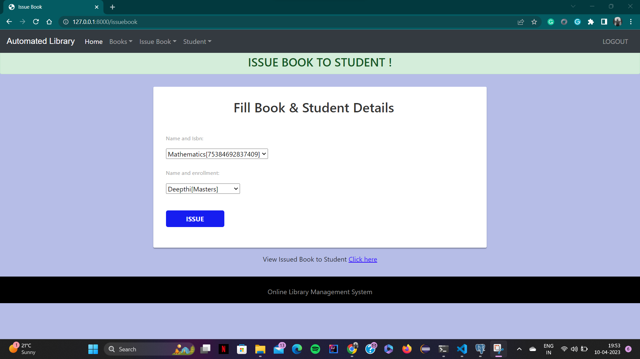

Now, the admin can click on “issue” button to issue the mentioned book details to the mentioned student details. After clicking this button the page redirects as the following

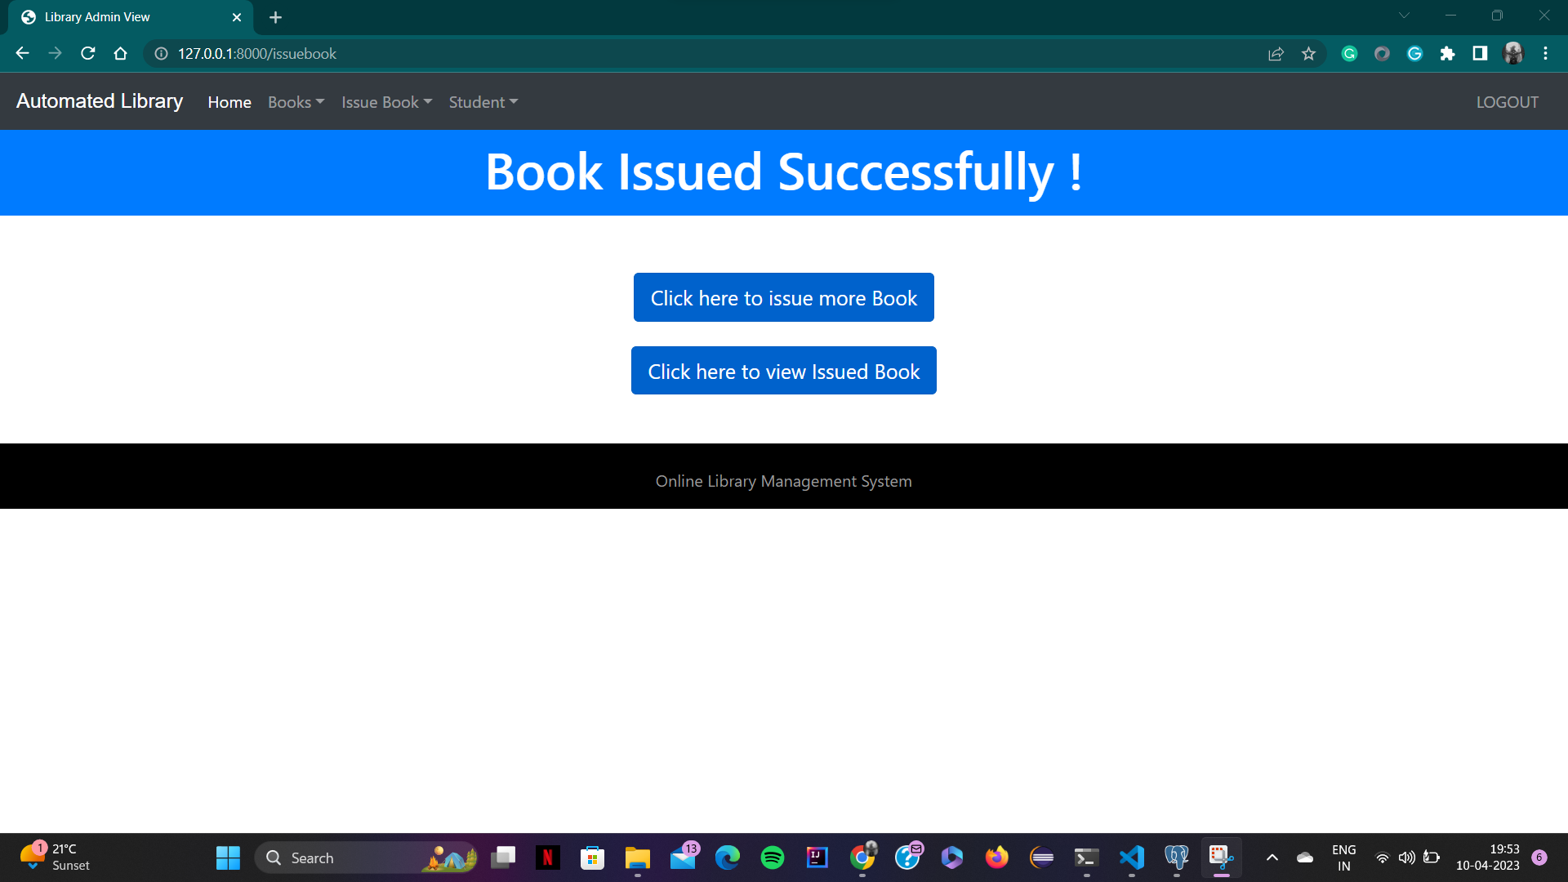

To view the books issued, admin has to click on “click here to view issued book” butto. After clicking this button we can see following page

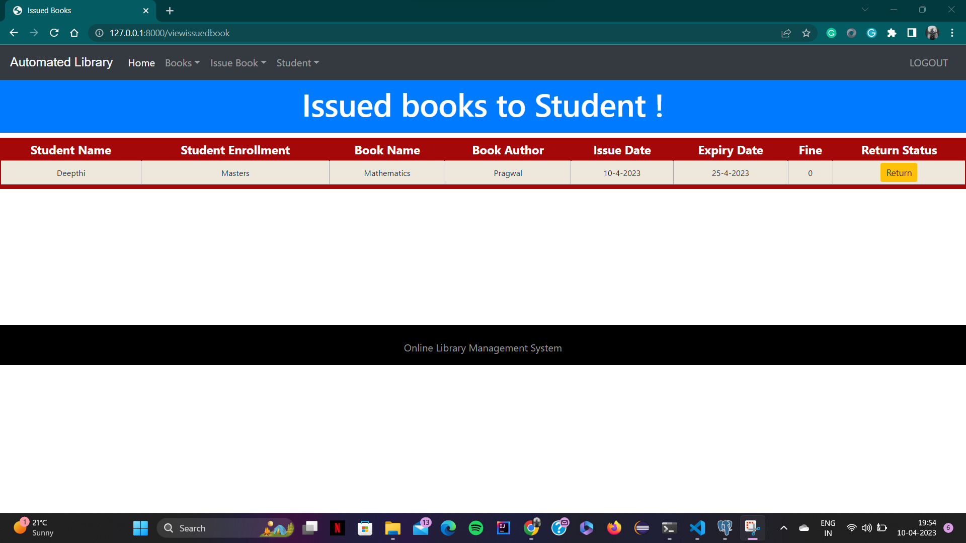

Now, the last functionality of the admin is that he can view all the students registered to the library by clicking on “view student” button. This can be viewed as shown below.

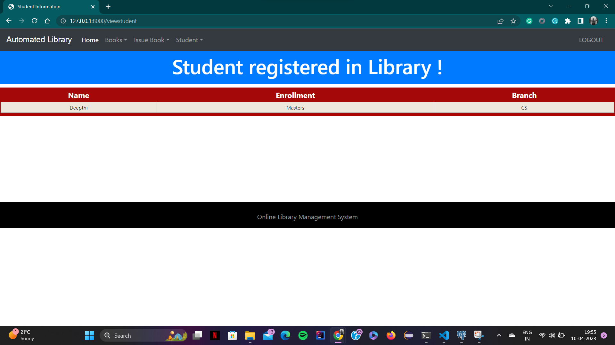

Now, to get into the student portal click on the logout button on the top right corner of the screen, then one redirects to the home page as below.

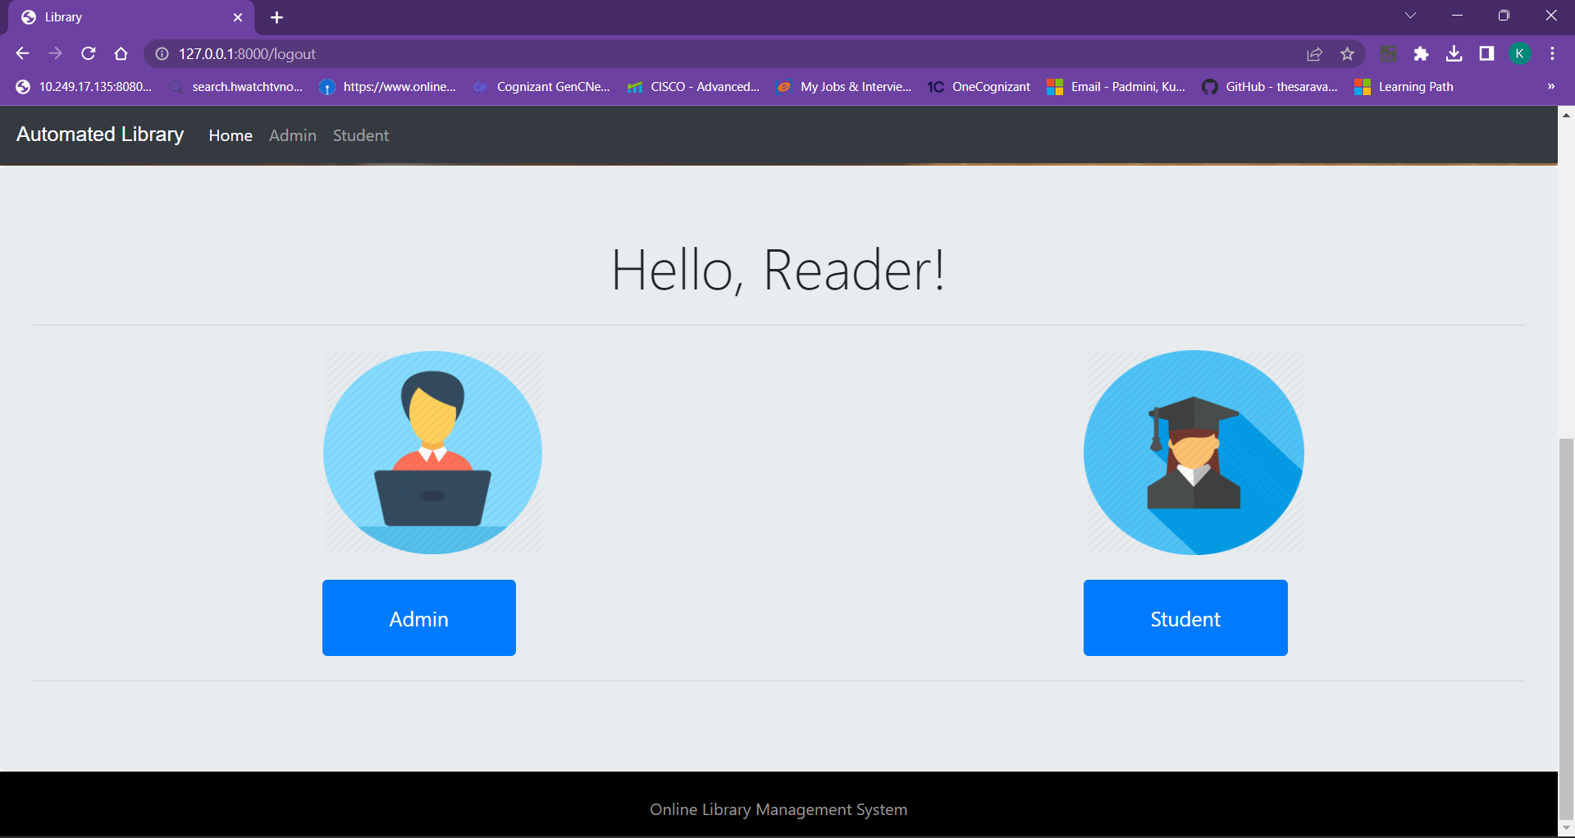

Now the user can either click the Student button which is in blue color or directly the Student button which is on the top left corner of the screen.Then, he/she can view the following screen.

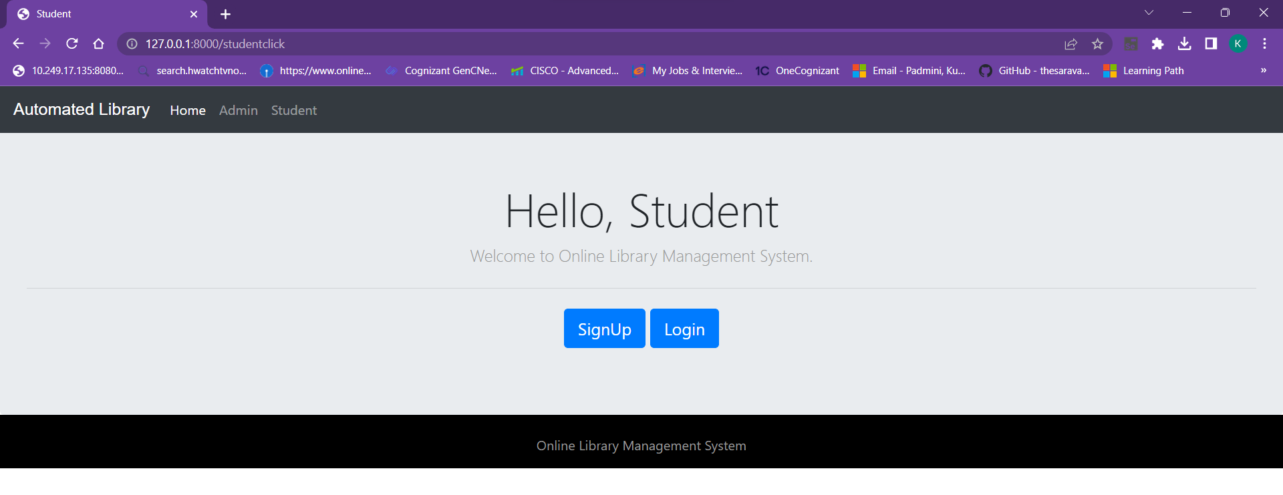

If the student is using our website for the first time, he/she can click on the signup. This redirects the user to the student signup page, which looks like the following.

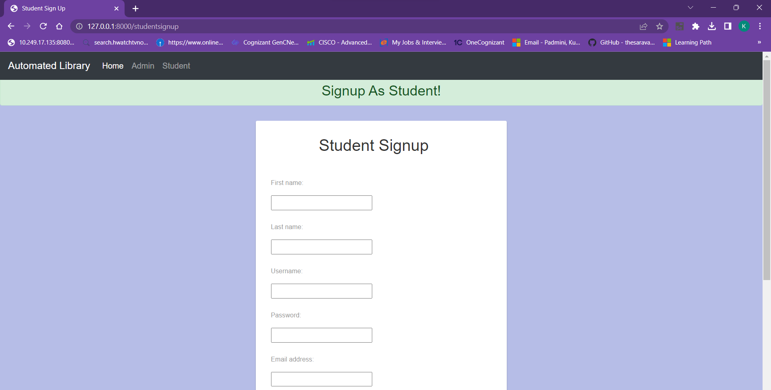

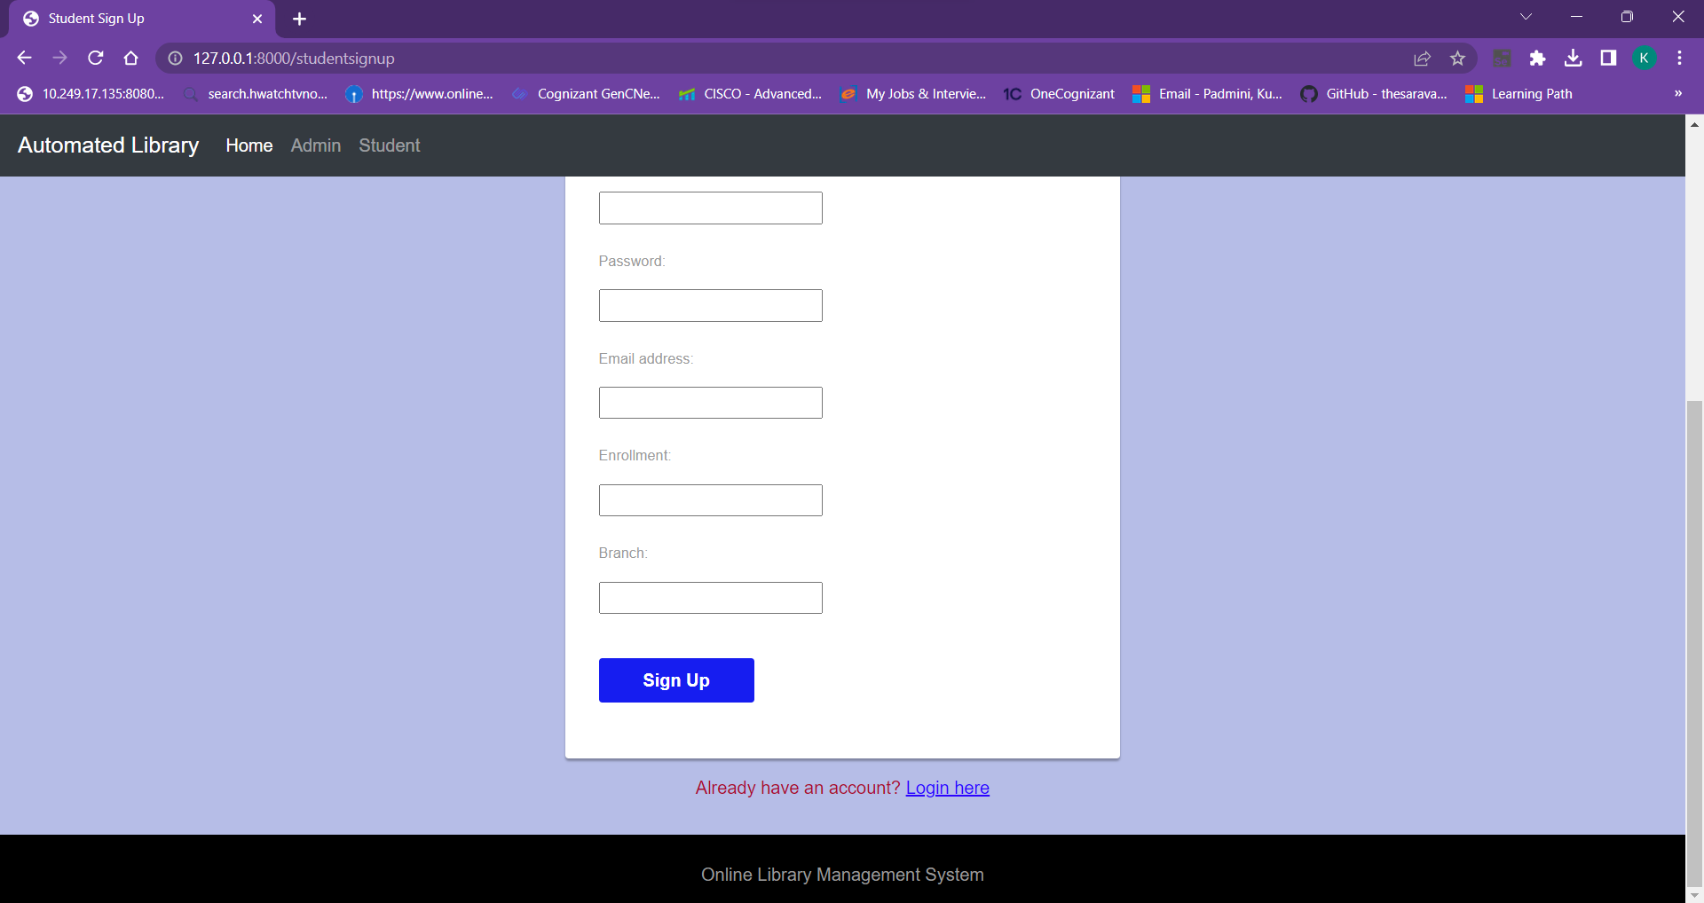

Provide the required details for signing up as shown below.

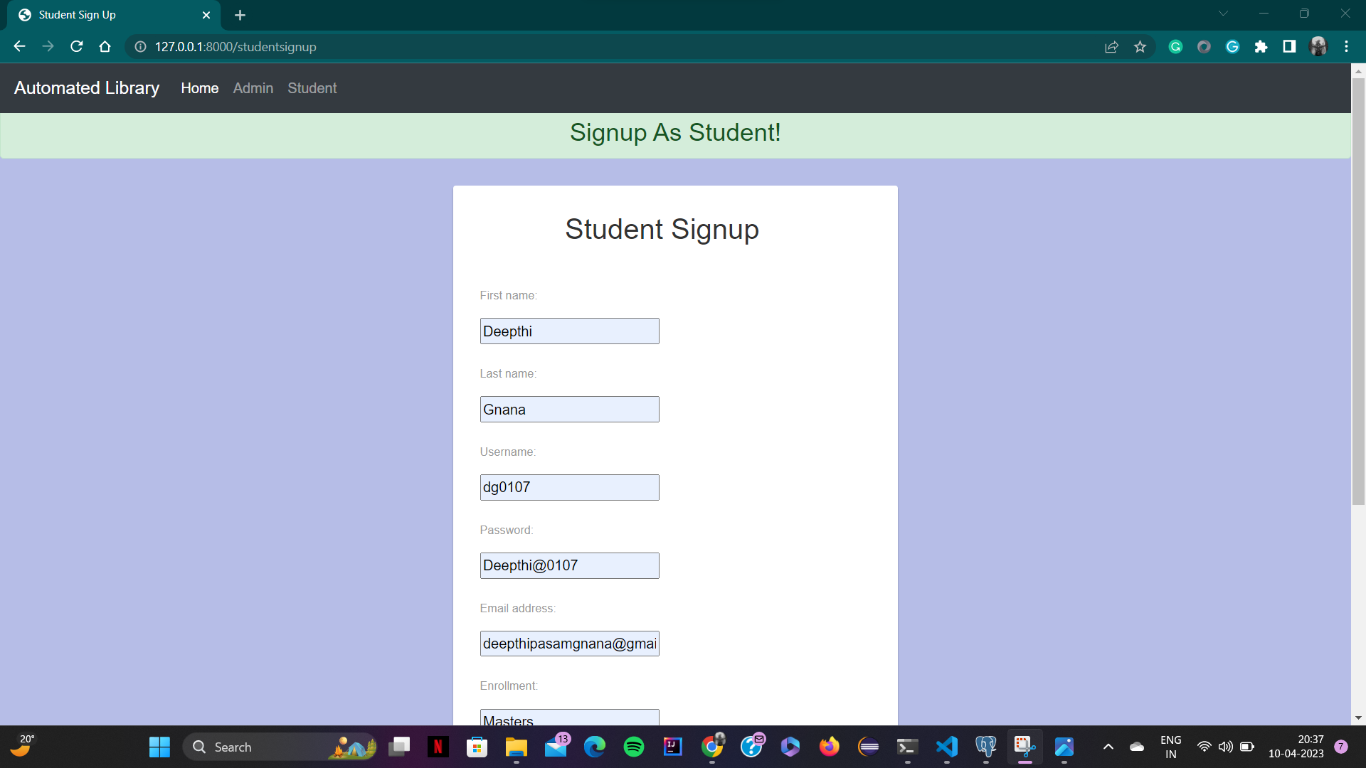

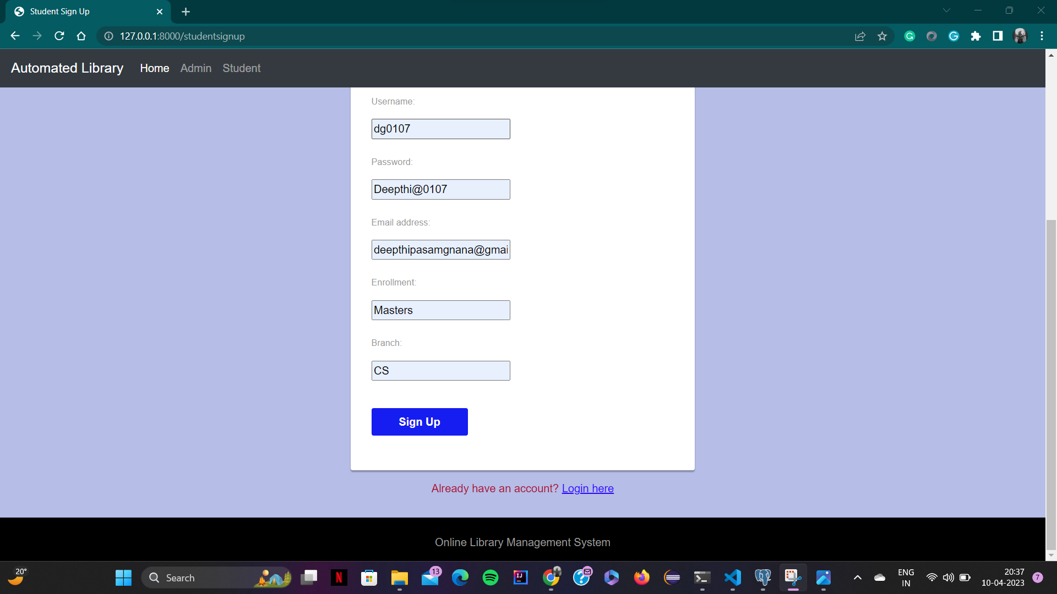

After giving details, one can click on the Sign Up button. Then, it redirects to the login page as below.

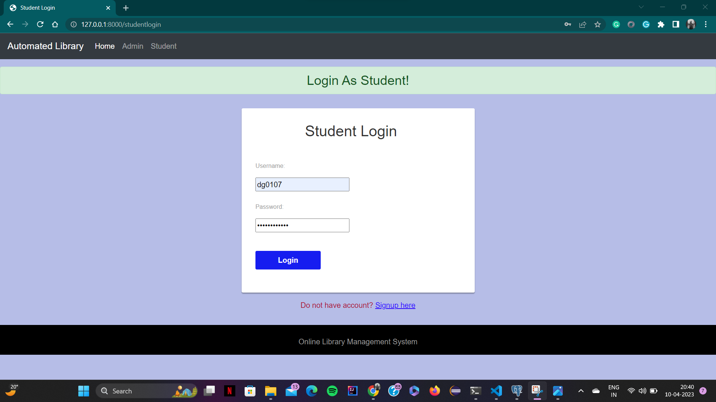

After successful login, one can view what all the functionalities can be performed by the student as below.

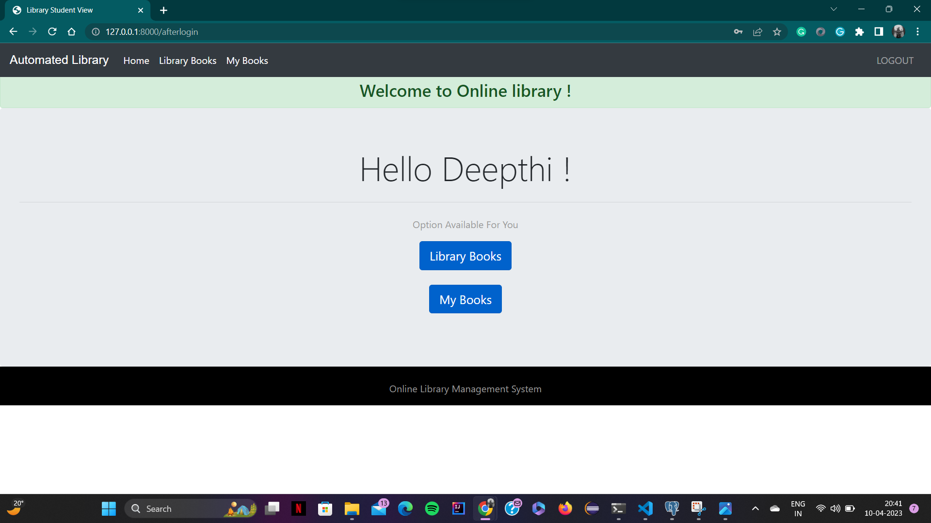

Now, as we can see above student can view their books by clicking on “My Books” button. After clicking on this button, it redirects to the following page as below.

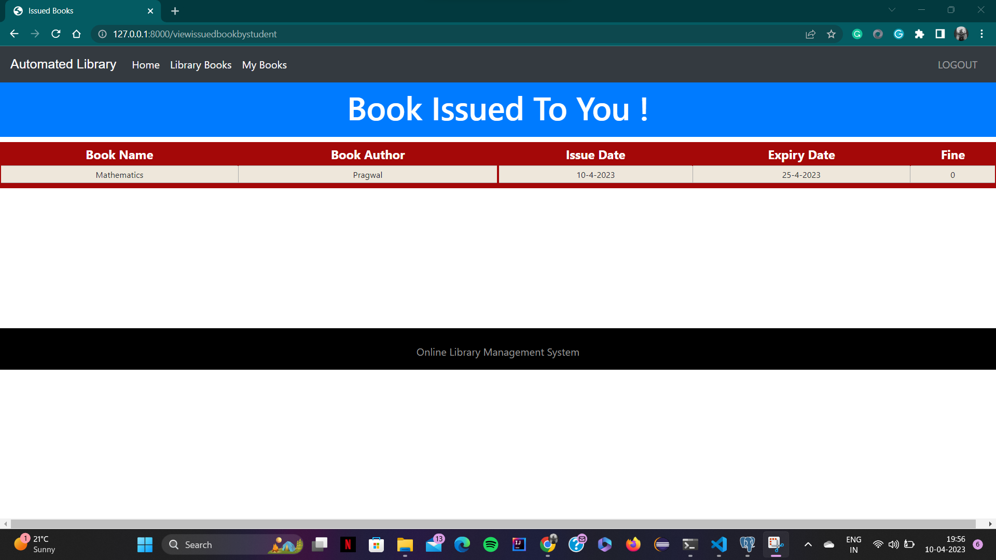

As the other functionality of the student, he can see all the books available in the library by clicking on “Library Books”. By clicking on this, one can see the following page.

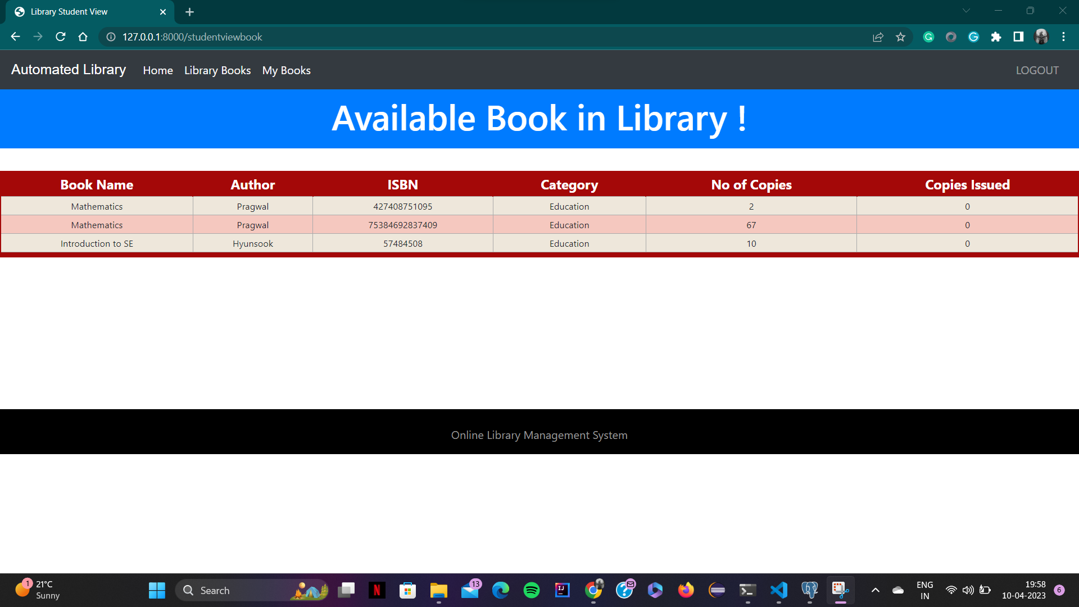

**e. Compilation Instructions**

For the ease of connecting backend and frontend, we are using the django framework to build our project.

To compile/execute our project, the basic requirement is the system you are working on should have python.

If there is no Python, then download and install the latest version, here we are using Python 3.10 using the following link.

<https://www.python.org/downloads/>

After successful installation of Python, installed django-admin as shown below using following command

pip install django-admin

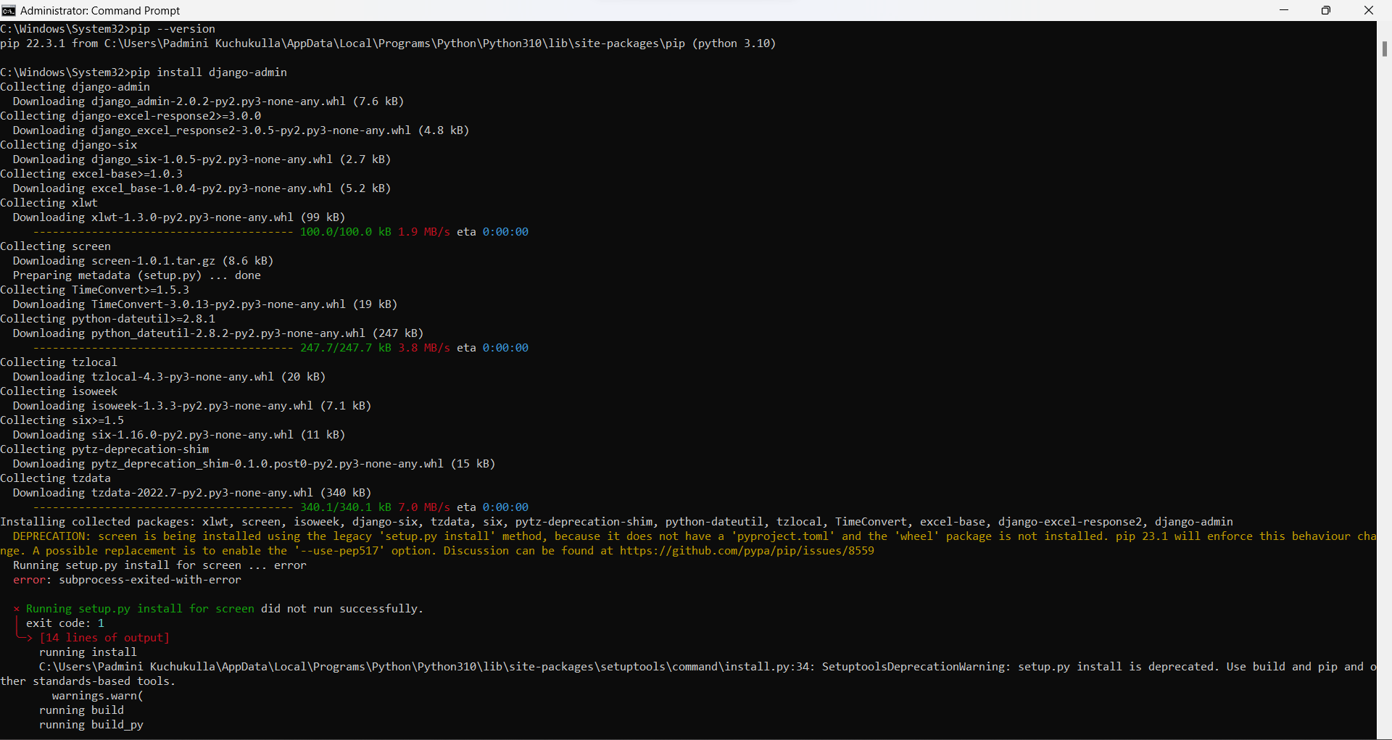

After this installed the virtualwrapper, this is because we are creating our whole project in separate virtual environment using the following command

pip install virtualenvwrapper-win

After installing the wrapper for windows, now created an environment for our project using the following command

mkvirtualenv penguins

As soon as we create the virtual environment named “penguins”, we will start working on the environment.

Now, in the environment we have installed django using the following command.

pip install django

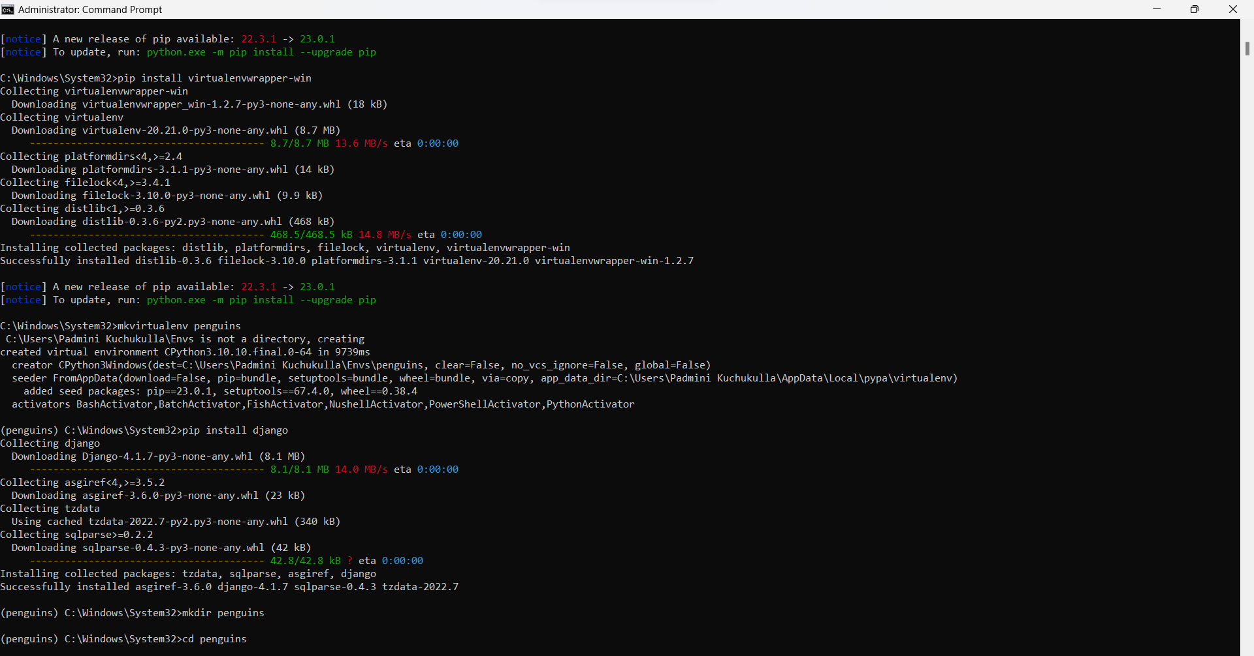

Now, after successful installation of django, we created the directory named “penguins” in the virtual environment using the following command

mkdir penguins

Now, change the path to the newly created directory using the following command

cd penguins

Now, in this directory we start our project using the django framework command which is as follows

django-admin startproject OnlineLibraryMangementSystem

After successful creation of the project directory, change the working path to this directory using the following command

cd OnlineLibraryMangementSystem

Now, to get the webpage link, we used python command which is as follows

python manage.py runserver

The manage python file is created by django in default when we start the project.

In the output we can see our website link as <http://127.0.0.1:8000/>

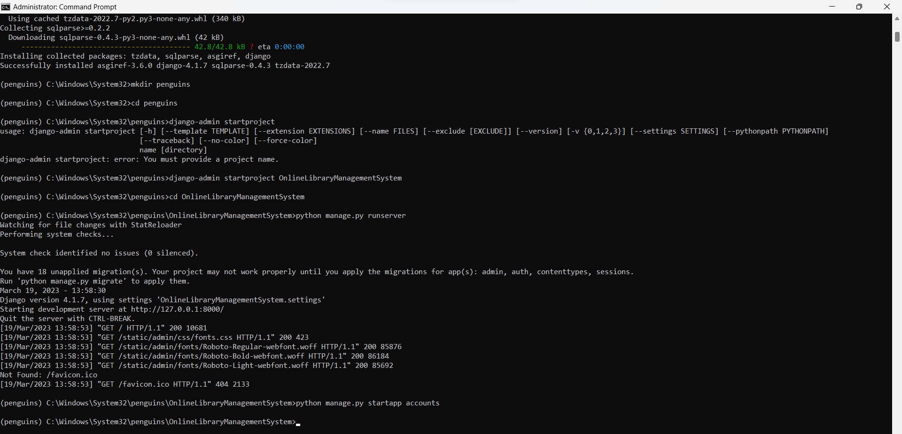

Now, when we open the link, we can just see that installation is successful.

Then, download and install postgresql, here we downloaded the 14.7 version using the following link

<https://www.enterprisedb.com/downloads/postgres-postgresql-downloads>

After successful installation of postgresql, now download and install pgadmin4, here we downloaded the 6.19 version using the following link

<https://www.postgresql.org/ftp/pgadmin/pgadmin4/v6.19/windows/>

Now, we created a folder named “templates”, which contains all the html files required for our project, which are coded separately by all of our teammates.

Then, we also created a folder named “static”, which contains another folder inside it named “images”, which contains all the images we used in developing the frontend.

While we are setting up these, it asks for a password, which we gave it as “Penguins”. This should be updated in the settings.py file, which is created by django in default.

After this step, we will try to run the server using the following command

python manage.py runserver

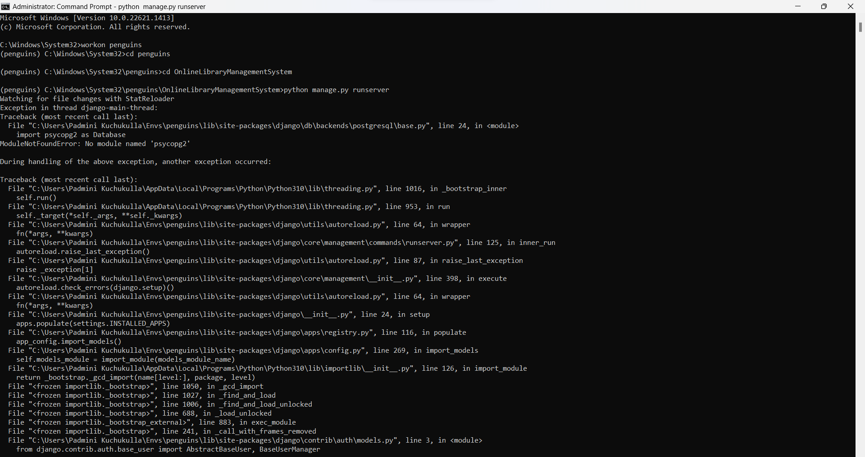

Now if all the required modules were installed, we would be able to see the frontend working fine on our webpage. But we can see the ModuleNotFoundError, which says there is no “psycopg2” module. This module is used as the database connecting adapter to postgresql. So, now we install this module using the following command.

pip install psycopg2

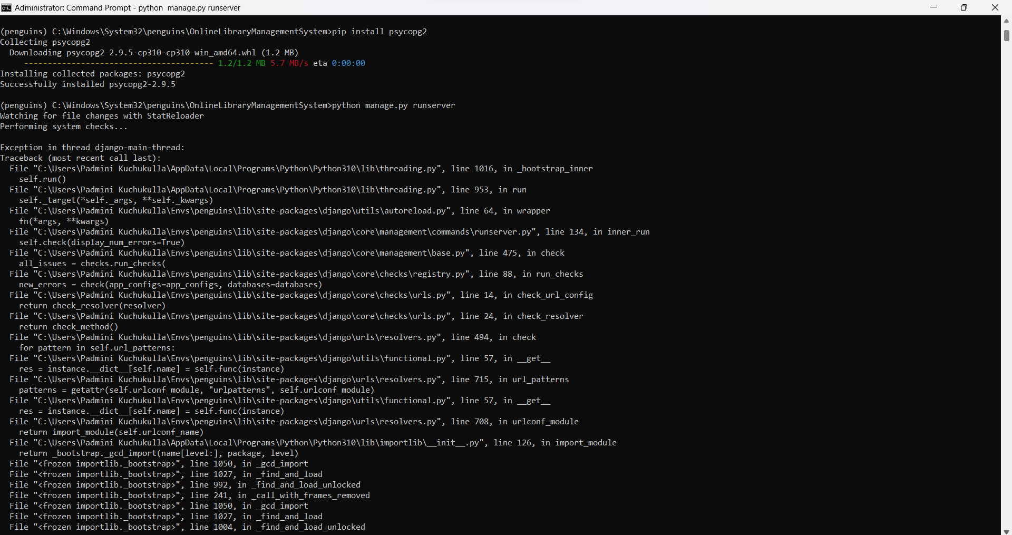

After this step, again we will try to run the server using the following command

python manage.py runserver

We can see the ModuleNotFoundError, which says there is no “requests” module. This module is used for handling all the http requests. So, now we install this module using the following command.

pip install requests

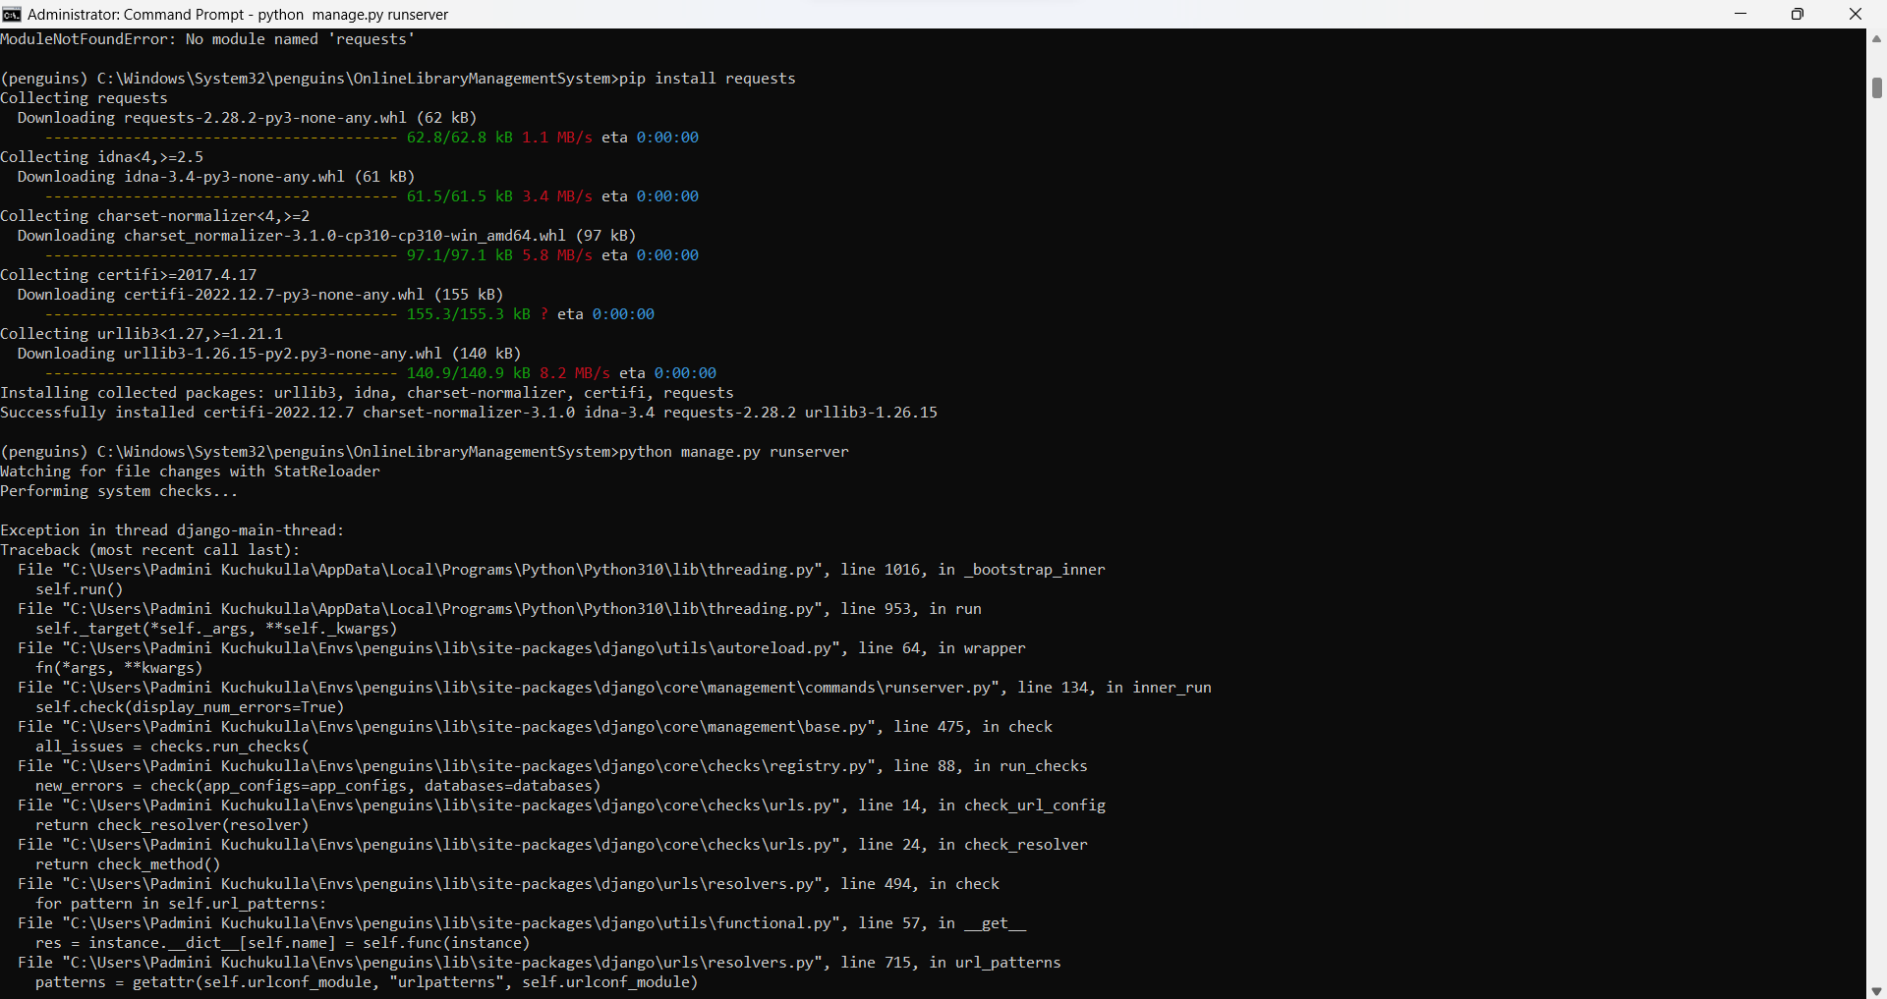

After this step, again we will try to run the server using the following command

python manage.py runserver

We can see the ModuleNotFoundError, which says there is no “bs4” module. This module is beautifulsoup4, which is used for web scraping. So, now we install this module using the following command.

pip install bs4

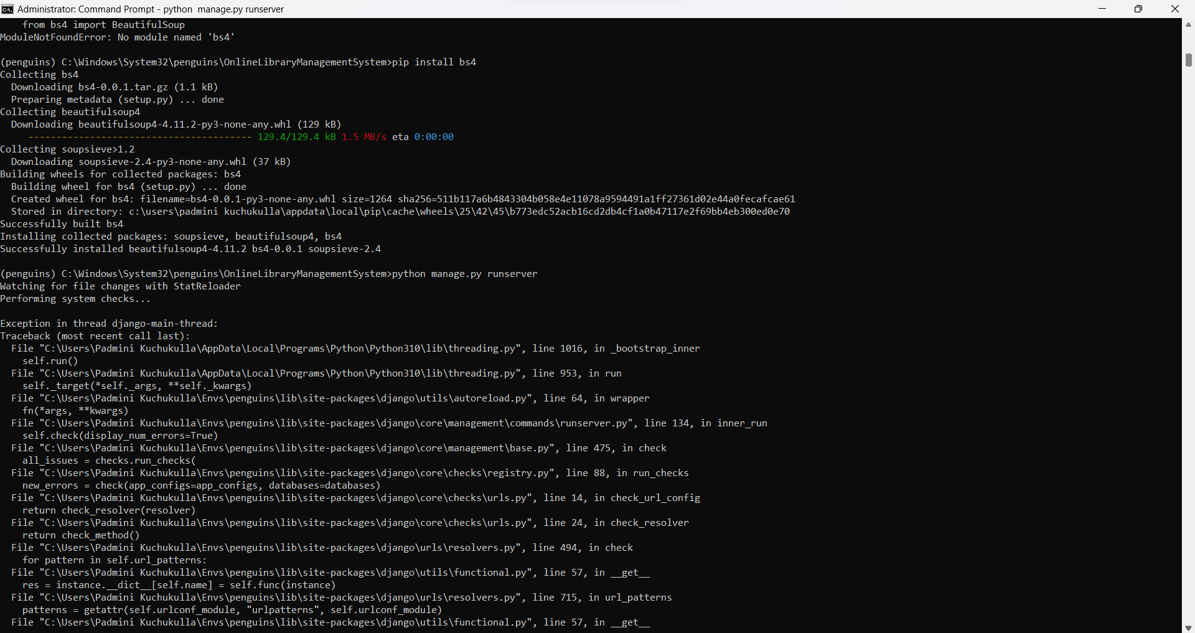

After this step, again we will try to run the server using the following command

python manage.py runserver

We can see the ModuleNotFoundError, which says there is no “speech_recognition” module. This module is used for recognizing speech, which we will be using for voice-based search. So, now we install this module using the following command.

pip install SpeechRecognition

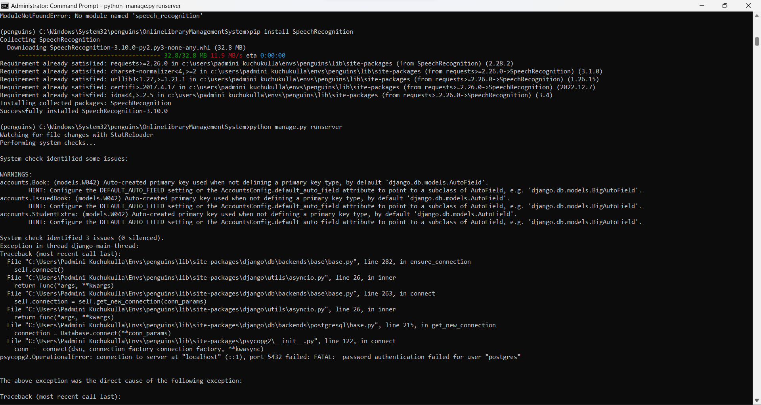

After this step, again we will try to run the server using the following command

python manage.py runserver

**f.Peer review feedback:**

In the peer review session, the team had discussed the concerns that we might face during the table creation and their usage to create the views. Feedback was received on how to improve the views and backend table optimization for the Online Library System. Based on this feedback, several actions were taken to enhance the system.

Backend Table Relations: The table relations in the backend were optimized to ensure efficient data storage and retrieval. This involved revising the table structures and relationships to better align with the intended features of the system, such as having separate tables for issued books, books, students, and their information.

Working Webpages: The suggested improvements were implemented to develop working web pages that seamlessly connect with the backend. The webpages were designed to provide simple views for the users, allowing them to easily browse, and manage books, students, and issued books for the students and admin views.

As an improvement, we decide to go with already planned alerts about the status of the webpages for all the webpages and rather than previously planned phase 2 implementation of creating admin feature to the website we had combined the phase 2 and phase 3 implementation of both the admin and student feature for the phase 2 and completely having new goals for the phase 3 with having search features, categorization for the phase 3 and additional testing.

In summary, the team discussed concerns about table creation and views for the Online Library System. Feedback was used to optimize table relations, develop working webpages, and implement alerts for webpage status. Phases 2 and 3 were combined to add admin and student features, while phase 3 will focus on search features, categorization, and additional testing. The team took valuable feedback and turned it into concrete actions to improve the system.

**g.Reflection:**

In phase 2 we accomplished all the goals we had originally planned and further added the original phase 3 features to the already existing schedules and accomplished that too. In this phase we had worked in groups of 2 and 3 to accomplish the assigned tasks of web page integrations with the database which was created by the other groups and another team was working on the testing for phase 2.

While doing this, help could optimize the tables and web pages and all the errors that were faced with brainstorm meetings. In this collaborative manner we were capable of developing the whole original phase 2 with add ons from phase 3. We did add the alerts to already existing phase 1 front end code and generalized for the whole UIs.

The constant feedback and help from one another were able to complete the assigned tasks successfully with minimal redundancy and little code debt with improvement to the front end pages too. We believe that these changes will help to have a smooth implementation of phase 3 objectives and successful completion of the project as a whole.

**Member’s Contribution:**

| **Member name** | **Contribution description** | **Overall Contribution (%)** | **Note (if applicable)** |
| --- | --- | --- | --- |
| Ashraf Syed | Requirements, Meeting minutes updation, involved in building the code and unit tests | 14.3% |  |
| Padmini Kuchukulla | Contributed in pushing code to github, user manual, code compilation,involved in building the code | 14.3% |  |
| Abhijith Reddy Mandagiri | Contributed in Test cases, Reflection, Review feedback from peer Evaluation, involved in building the code | 14.3% |  |
| Deepna Thalanki | Contributed in UML diagrams, involved in building the code | 14.3% |  |
| Raghu Vamsi Kondapalli | Contributed in UML diagrams, involved in building the code, Contributed in test cases. | 14.3% |  |
| Vamsi Venkat Manepalli | Involved in building the code, Contributed in test cases. | 14.3% |  |
| Sai Vishwak Jadala | Involved in building the code, Contributed in test cases. | 14.3% |  |